..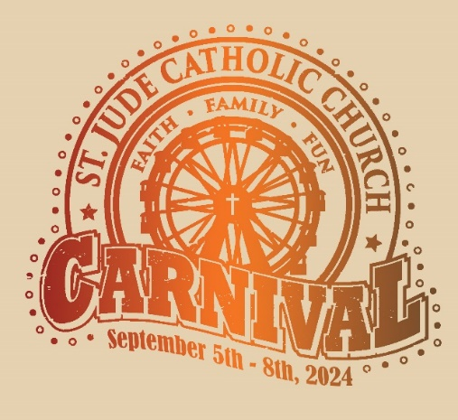
ST. JUDE CATHOLIC CHURCH 18th ANNUAL CARNIVAL
September 5 – 8, 2024
Thurs. 6-10 PM * Fri. 6-11 PM * Sat. 3-11 PM * Sun. 3-10 PM
______________________________________________________________________________
ST. JUDE CATHOLIC CHURCH
1515 North Greenville Avenue, Allen 75002

OPEN TO THE PUBLIC!
FREE ADMISSION & PARKING!
BENEFITS YOUTH OUTREACH & ST. JUDE YOUTH PROJECTS
_____ _____ _____ _____ _____ _____ _____

THURSDAY: UNLIMITED RIDES NIGHT
NO REFUNDS FOR ANY REASON. Must meet posted height requirements for rides and activities.
_____ _____ _____ _____ _____ _____ _____
SATURDAY ST. JUDE COURTYARD CARNIVAL FESTIVITIES
ALL ARE WELCOME!
ST. JUDE COURTYARD 2-7 PM * INSIDE FOOD 1-8 PM

Food * Games for all ages * Music * Face painting * Raffle
* Silent Auction & MORE!

For more Information, especially ride ticket prices: www.stjudeparish.com/carnival

